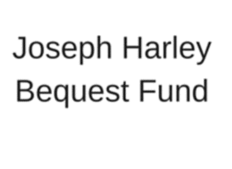
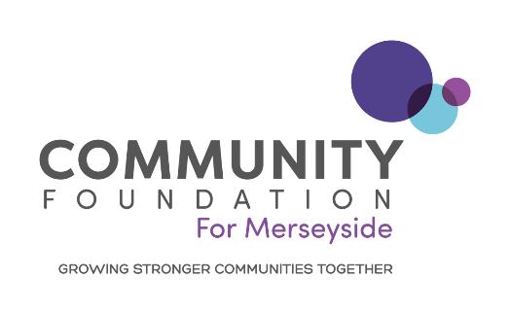

GRANT APPLICATION FORM FOR INDIVIDUALS

Before applying, please ensure that you have read the accompanying Grant Guidelines

Please note that only completed applications will be processed. When submitting your application you need to ensure you have submitted all relevant documents. If all the documents are not received your application may be rejected.

Section 1: About You
1. Your Name

2. Name of fund you wish to apply to

NB: we will consider which fund your proposal is best suited to and may transfer the application to another Donor fund programme in order to maximise its chance of success

3. Your Date of Birth / /
4. Do you consider yourself to have a disability? | YES |  | NO
5. Please give details of your full address, including postcode
Address:
Town:
Postcode:
Telephone:
Mobile:
Email:
Best time to contact:
6. School/College/University currently attending (if applicable)

7. Where relevant, please give details of any qualifications you hold or achievements made

Section 2: Your Request For Funding
8. Please provide details about what you would like the funding for

9. Please tell us why you feel that you need financial assistance

10. How will you record the impact that the funding has made?

Vital Signs- Please select a vital signs theme category that your project most closely relates to (please just select one)

Arts, Culture and Heritage |  | Environment
Healthy Living |  | Housing and Homelessness
Learning |  | Local Economy
Rural Communities |  | Safety
Stronger Communities |  | Work
Fairness

Section 3: Your Requested Costs
11. How much are you applying for in total? |  |  |  | £
12. What is the total cost of your project? |  |  |  | £
13. How much of the shortfall do you currently have? |  |  |  | £
(a) If you do not already have the shortfall, how will it be met?

14. Please provide a full breakdown of your requested costs
Item | Amount £ | Amount requested | Description / Breakdown of Cost
TOTAL | £

Section 4: Your Declaration
15. How did you hear about the programme? (please tick all that apply)
 | Local funder website |  | Other website
 | Community Foundation website |  | Voluntary and community sector networks
 | Local funder briefing event |  | Other event
 | Leaflet/brochure/newsletter |  | Local press
 | Outreach worker |  | Third sector press
 | National press |  | Word of mouth
 | Other (specify below)
Declaration: By signing this form I confirm that to the best of my knowledge, that all of the details are correct at the time of submission

Signature:
Full Name:
Date:

Thank you for completing this form.

Electronic forms can be returned to applications@cflm.email

Signature: ………………………………………………………………………………….

Name: …………………………………………………………………………………………

Date: …………………………………………………………………………………………

Registered Charity Number: 1068887
Registered as a Company Limited by Guarantee in England and Wales Number: 3422207

